HISTORICAL TOUR
To
GUNTUPALLI CAVES
(Jeelakarragudem, Kamavarapukota)
W.G. Dt-544406

Date: 20-12-2021
By
S. Soma Sekhar
Department Of History
Sri DNR Govt. Degree College for Women
Palakolu W.G. Dt, A.P

The Department of History has organized a historical tour to Guntupalli caves (Jeelakarragudem, Kamavarapukota) W.G. Dt on 20th dec 2021. In this program 9 staff members and 90 students (B.A, B.Com and B.Sc) participated.
HISTORY OF THE GUNTUPALLI CAVES
The Guntupalle or Guntupalli Group of Buddhist Monuments is located near Kamavarapukota, West Godavari district, in the state of Andhra Pradesh in India. It is around 40 km away from Eluru. The rock-cut part of the site has two Buddhist caves, a chaitya hall and a large group of stupas. The chaitya hall has a rare carved stone entrance replicating wooden architecture, a simpler version of that at the Lomas Rishi Cave.
There are remains of structural buildings in brick and stone, including remains of two vihara made of brick, as well as excavated caves at two levels, including an unusual structural chaitya hall (that is, one built above ground). The core of this consists of the stone stupa with an enclosed path around it allowing ritual parikrama (circumambulation). They mostly date to 200-0 BCE, with some sculptures added later. The main building above ground is in brick, around a stone stupa, with over 30 smaller stupas on a terrace in front of it. There are ruins of two other buildings.
During excavation, three relic caskets were found. The caskets had many precious elements like gold, silver, crystal beads. The bronze image of Padmapani was found along with one of the caskets. The inscription on the casket was in the Devanagari script which indicates the year as from the 9th to 10th century CE.

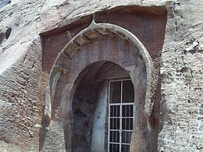
Entrance to the chaitya hall at Guntupalle

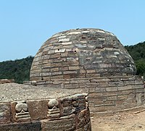

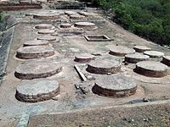

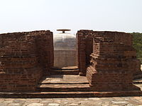
The stupa inside its buildings

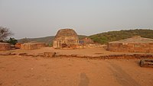
Stupas

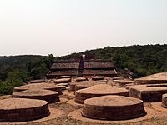
Stupa remains below the main stupa

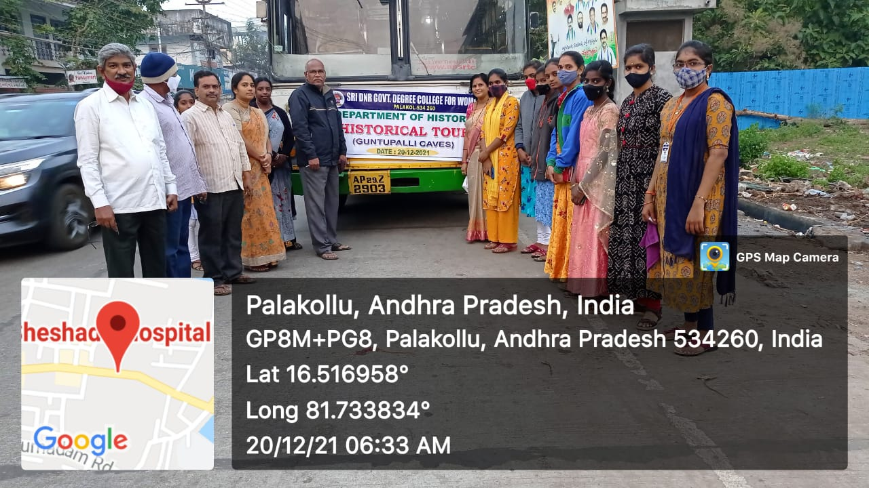

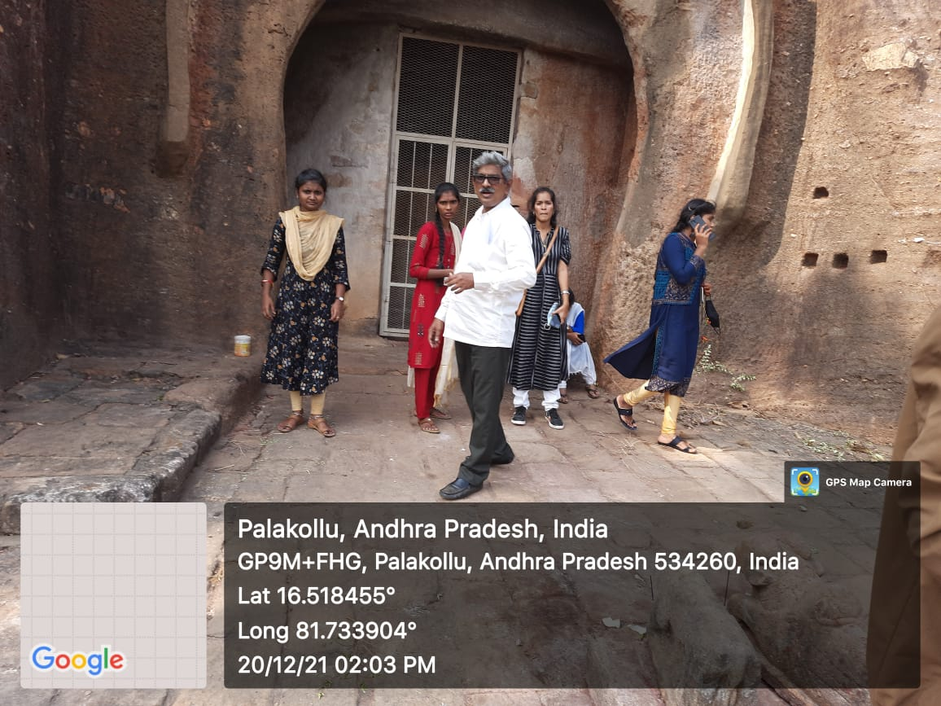
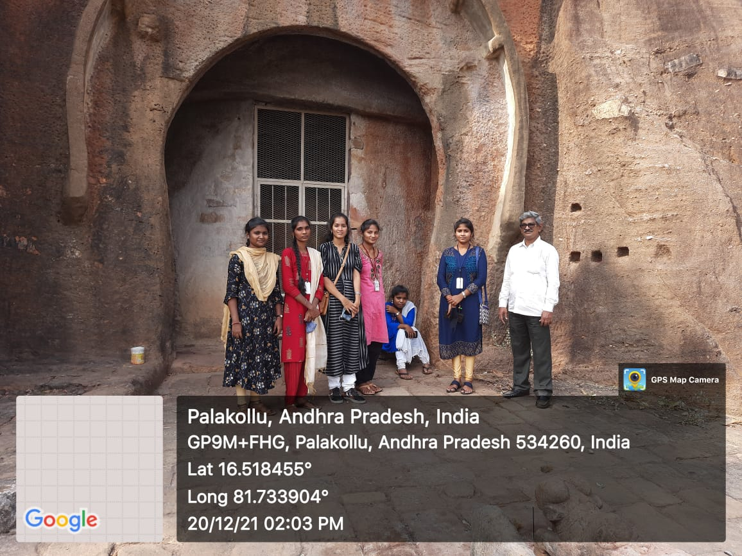

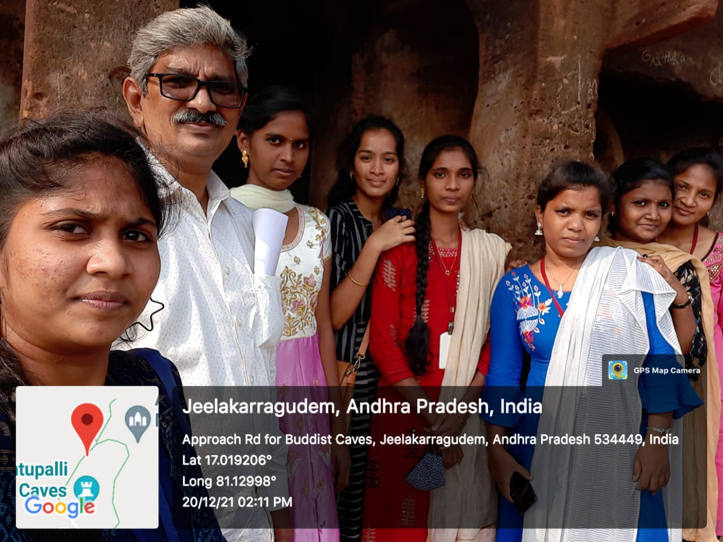
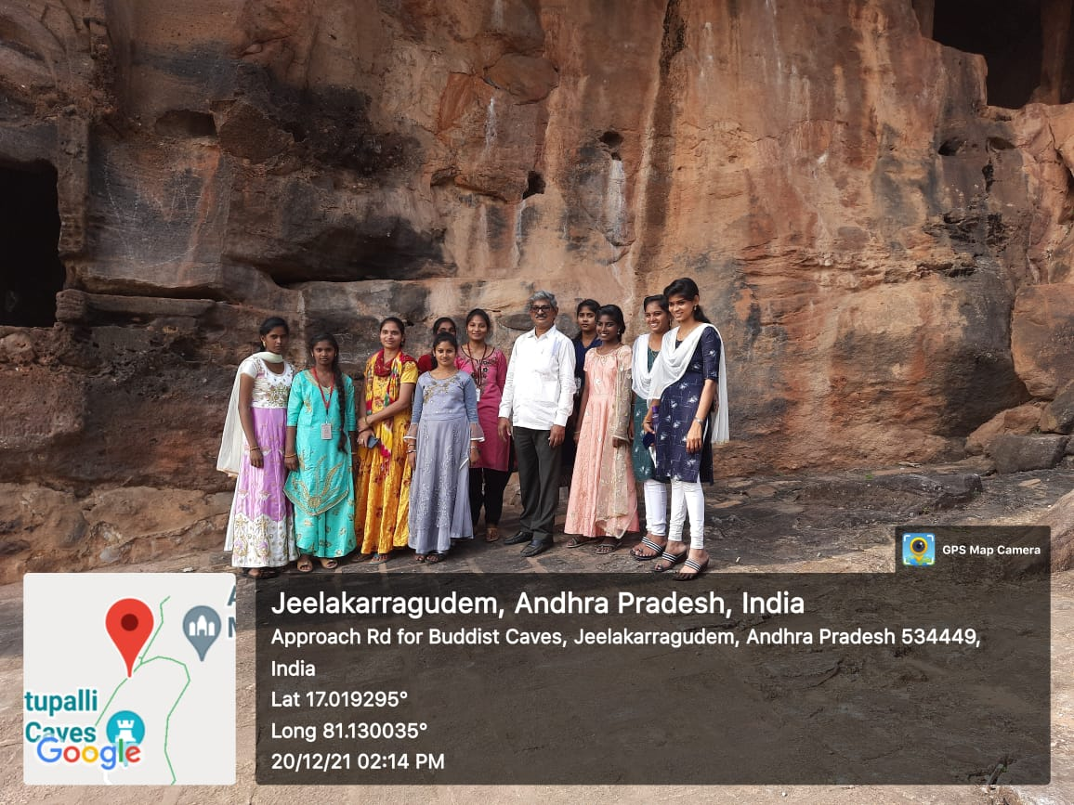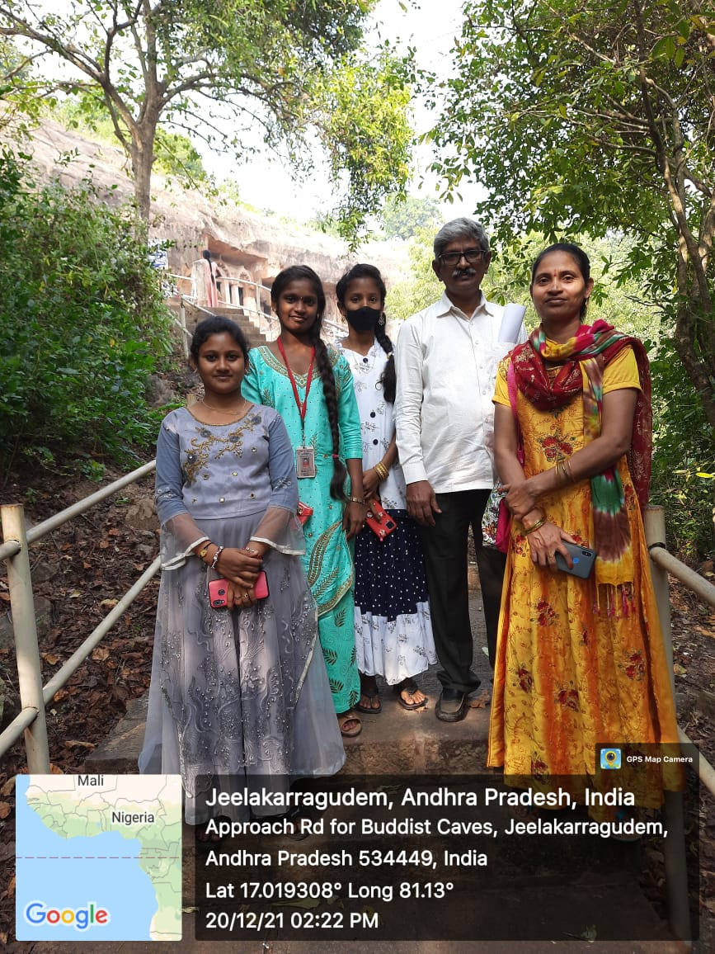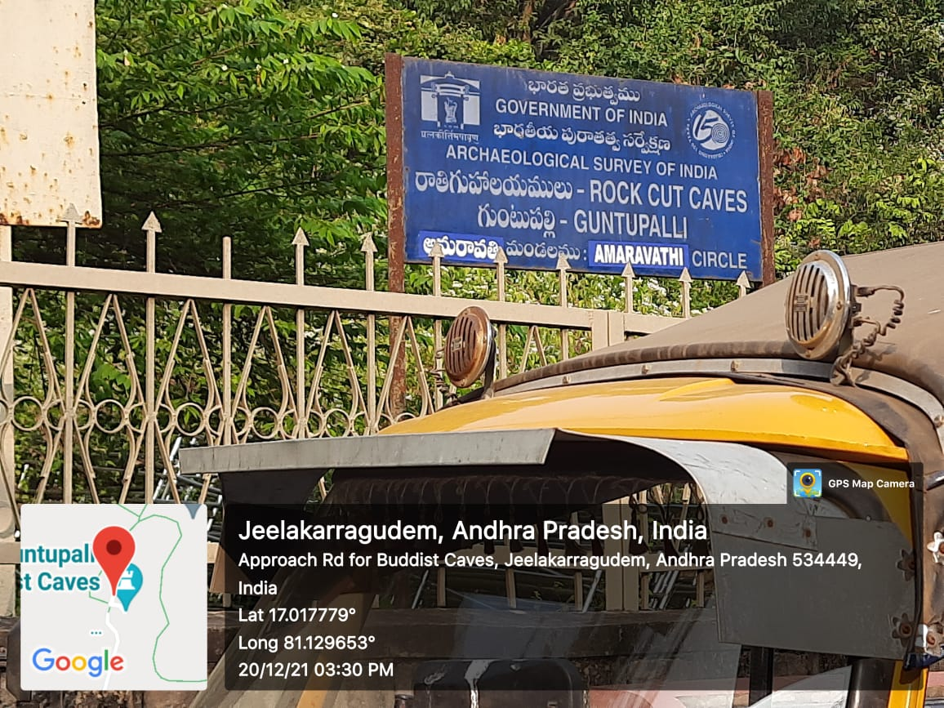

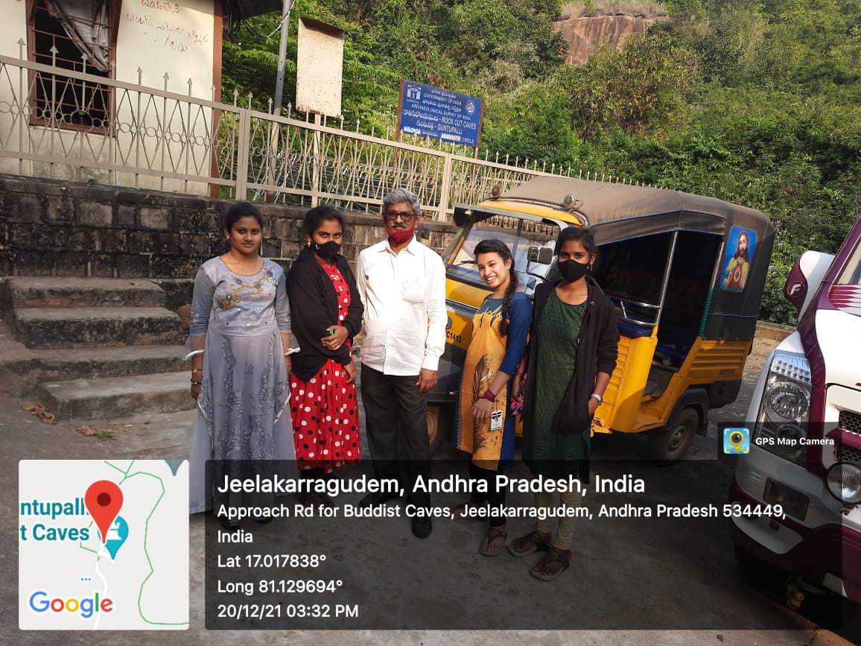

Conclusion:
This type of activities in colleges can improve thinking and working capacity of student. This also enable to the student to increase the knowledge and his will towards the research mode of education in their future life.
The main motto of the program is to enable the students to improve their knowledge and creativity leading them to become successful in their life.
Thank You

